Lower Limb Adductor Stretches

Side Lunge Stretch

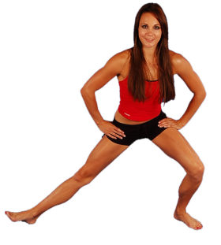

Stand with feet far apart, toes pointed 45° outward. Lunge toward one side. Allow foot of straight leg to point upward with heel on floor. Keep back straight during stretch. Hold stretch for 30 seconds, repeat on opposite leg. Do this stretch daily, 2 times a day.

You should feel a stretch on the inside of your thigh.

Short Adductor Stretch
Groin stretches performed with bent knees will target the short groin muscles. Assume the position as shown. Gently press down with the elbows onto the knees to increase the stretch. If it is painful then stop. You should feel a gentle stretching in the inner thigh. Hold stretch for 30 seconds, repeat on opposite leg. Do this stretch daily, 2 times a day.
Play short adductor stretch video.

Long Adductor Stretch
This groin stretching exercise will stretch the long adductor muscles that attach below the knee. Stand with your feet wide apart as shown, and lean away from the side you are stretching. Hold stretch for 30 seconds, repeat on opposite leg. Do this stretch daily, 2 times a day. This can also be done in a standing position to target the muscles differently.
Play long adductor stretch video.

Hip Flexors
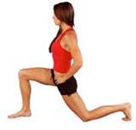
Although strictly not one of the groin stretches this exercise is still important. The adductor muscle assists in flexion of the hip or pulling the knee forwards and upwards. This will stretch the adductor muscles more specifically in the direction they are used for running. Assume the position as shown with one knee on the floor. Gently lean forward to increase the stretch. Hold stretch for 30 seconds, repeat on opposite leg. Do this stretch daily, 2 times a day.

Dynamic stretching
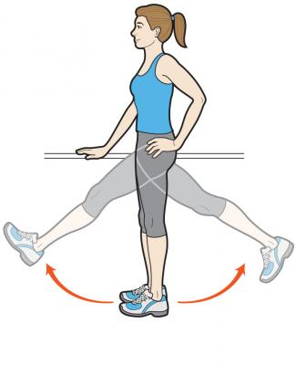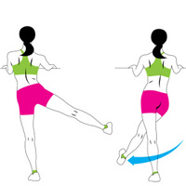
Dynamic stretching will stretch the muscle whilst it is moving and should be part of any warm up prior to any activity. Assume the position as shown and gently swing the leg in a relaxed manner. It should not be forced. Forcing the muscle is ballistic stretching and can cause damage to the muscles. Aim for 10-20 swings on each leg. A good, relaxed swing is what is required, gradually increasing the height of swing.

